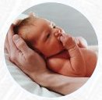
Natural family Planning (NFP) gives couples a reliable, natural, moral method of regulating the births of their children within marriage, should they so wish.
NFP teaches women to note their own personal fertility indicators on a daily basis to identify fertility so pinpointing the optimum time to try for a baby if desired, or to use abstinence during this period, if not. When used carefully, the method is over 99% reliable. NFP is completely safe and does not use hormones, chemicals or devices within the female body.
Depending on co-operation and discussion between husband and wife and reflecting the dignity of each of them as being made in the image and likeness of God, over fifty years of use have proven that this method deepens the marital bond, resulting in good family stability, openness to new life and a low rate of divorce amongst couples using natural family planning.
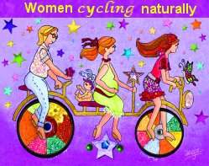
The Church teaches that children are "the supreme gift of marriage" (Gaudium et Spes n. 50). She also teaches that contraception is "intrinsically evil" because it takes away the 'life-giving' potential from the marital embrace. The total giving of self to each other, as promised on the wedding day in the exchange of vows, is no longer possible with the use of contraception or sterilisation because fertility, an integral part of each person, has been either suppressed or destroyed. The effective reasoning is thus: "I give you myself, but not my fertility. I will take steps to actively prevent my healthy reproductive system from working properly in case we create a baby and God infuses a soul into it." This action is 'anti-' of God and is, therefore, sinful.
On the contrary, when Natural Family Planning is used with the same intention of preventing the conception of another baby, it suppresses nothing because it works with the God created, natural periods of infertility within the menstrual cycle. It does nothing to change and pervert the actual act itself of which the Church maintains that "Each and every act must be open to the transmission of life." (Humanae Vitae n. 11)
Natural Family Planning South West has teachers across the diocese. To enquire about the method or to be put in touch with a teacher in your area, contact the coordinator, Christine Hudson, on 01752 224018 or email: chrishud78@talktalk.net

